Fortinet firewall

1. 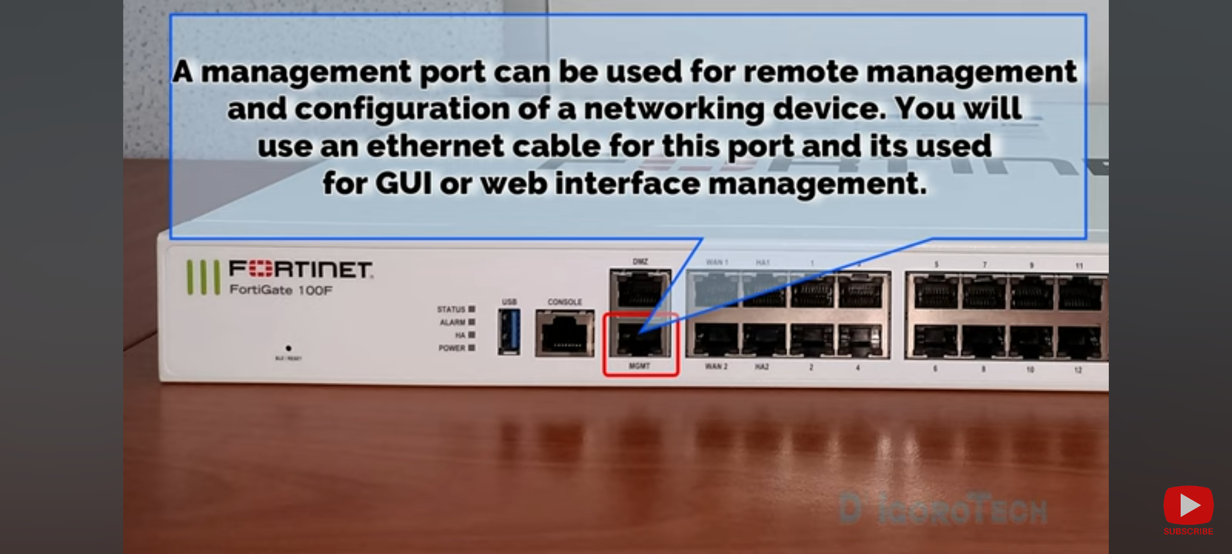
2. 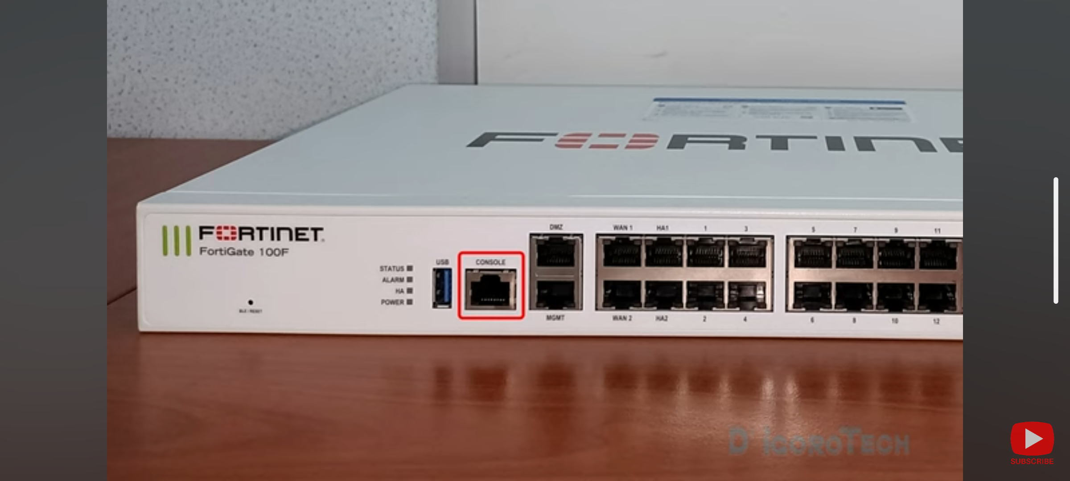

Console port is RJ45 port that will be used for CLI

management of the firewall.

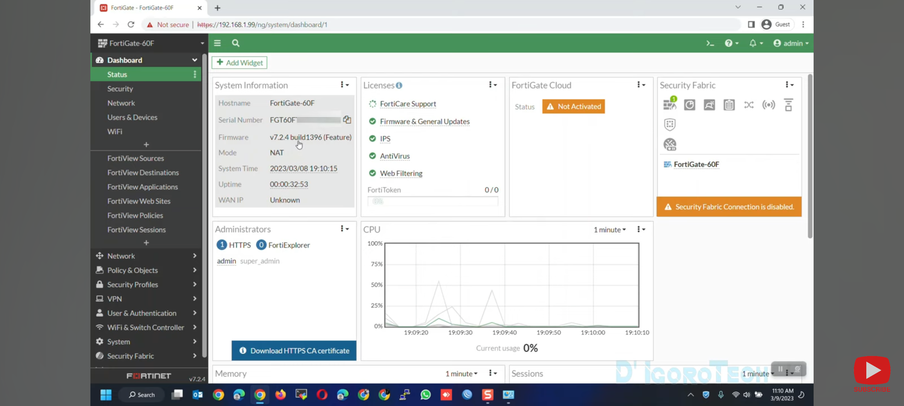

## CREATE ADMIN OR READ ONLY ACCESS ACCOUNTS

1. Network admin 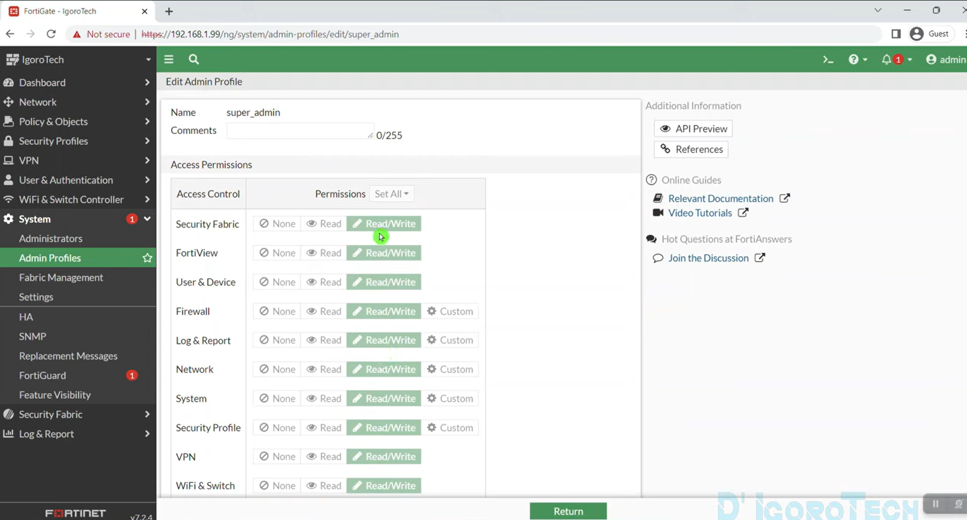
2. Super admin : can edit any of the above features.
3. 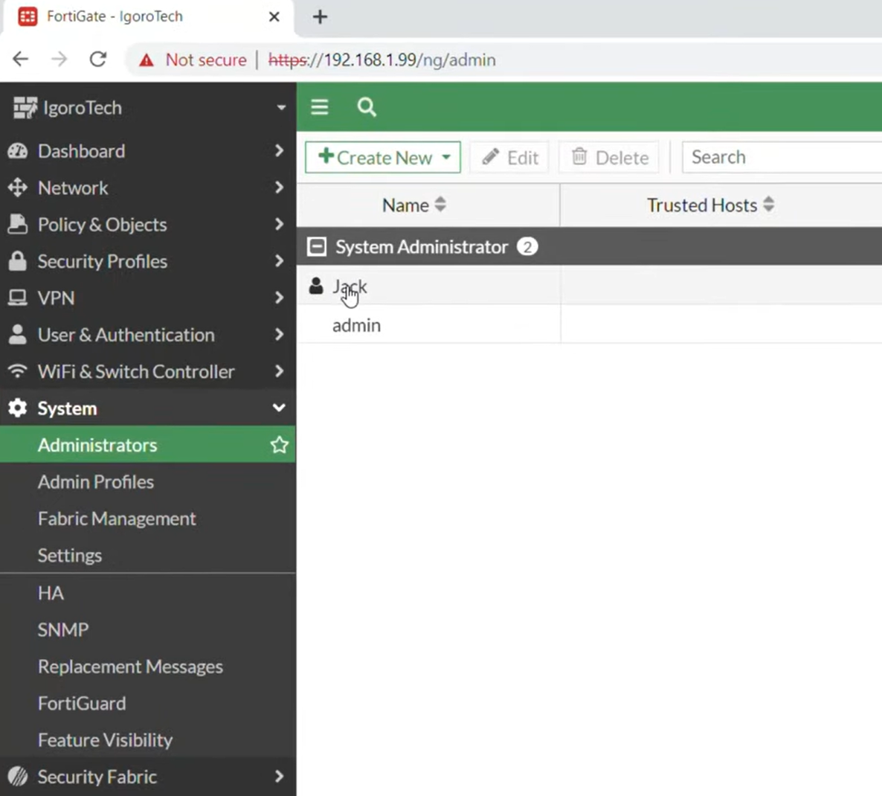
4. 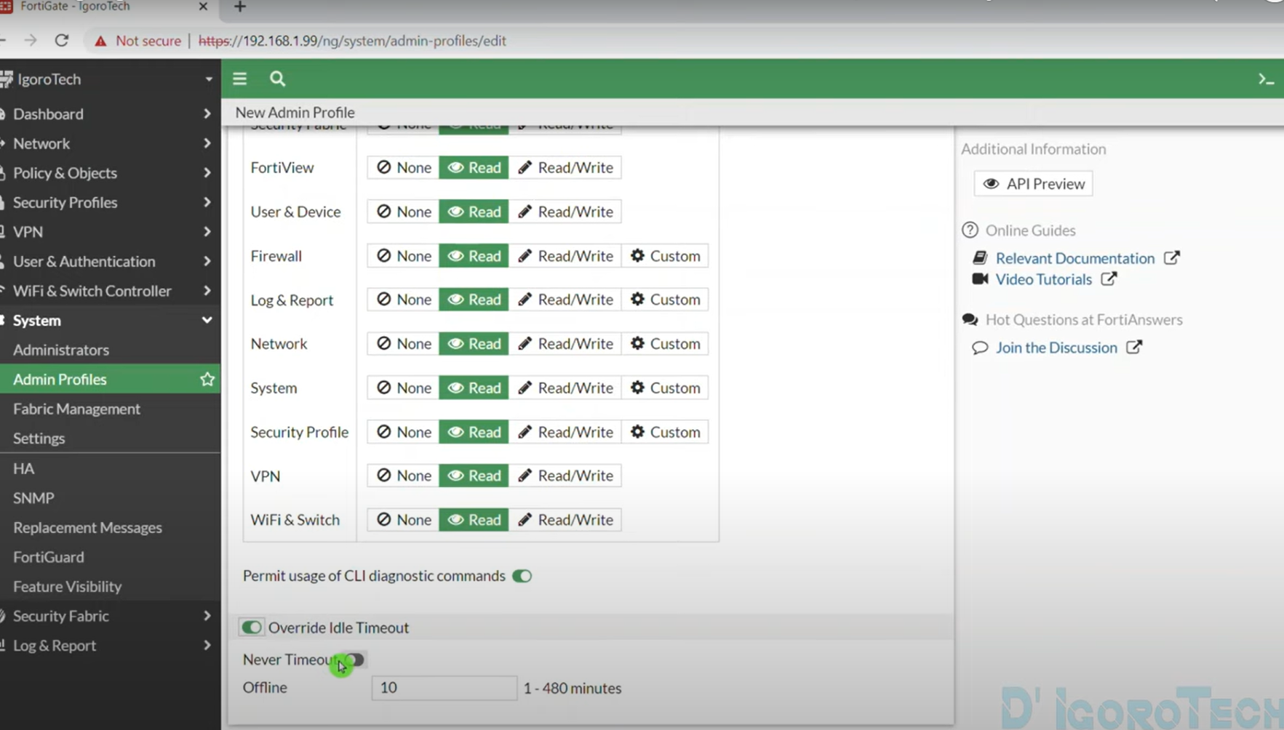

## CONFIGURE LAN,VLAN,DNS and DHCP

1. Navigate to Network > Interfaces

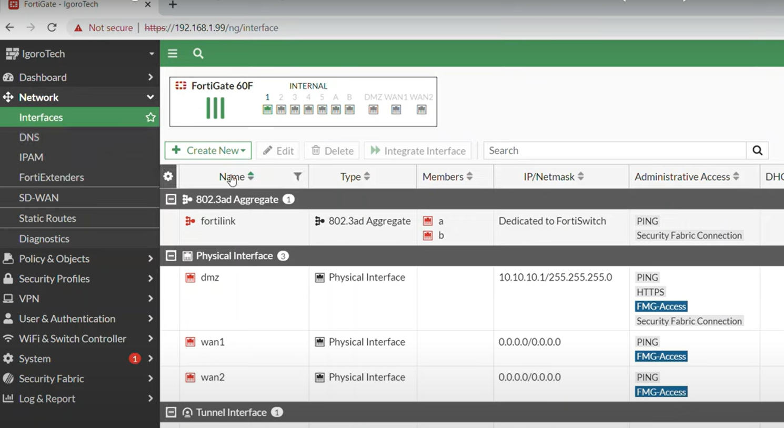

Below we see all the VLAN configurations that are already set up 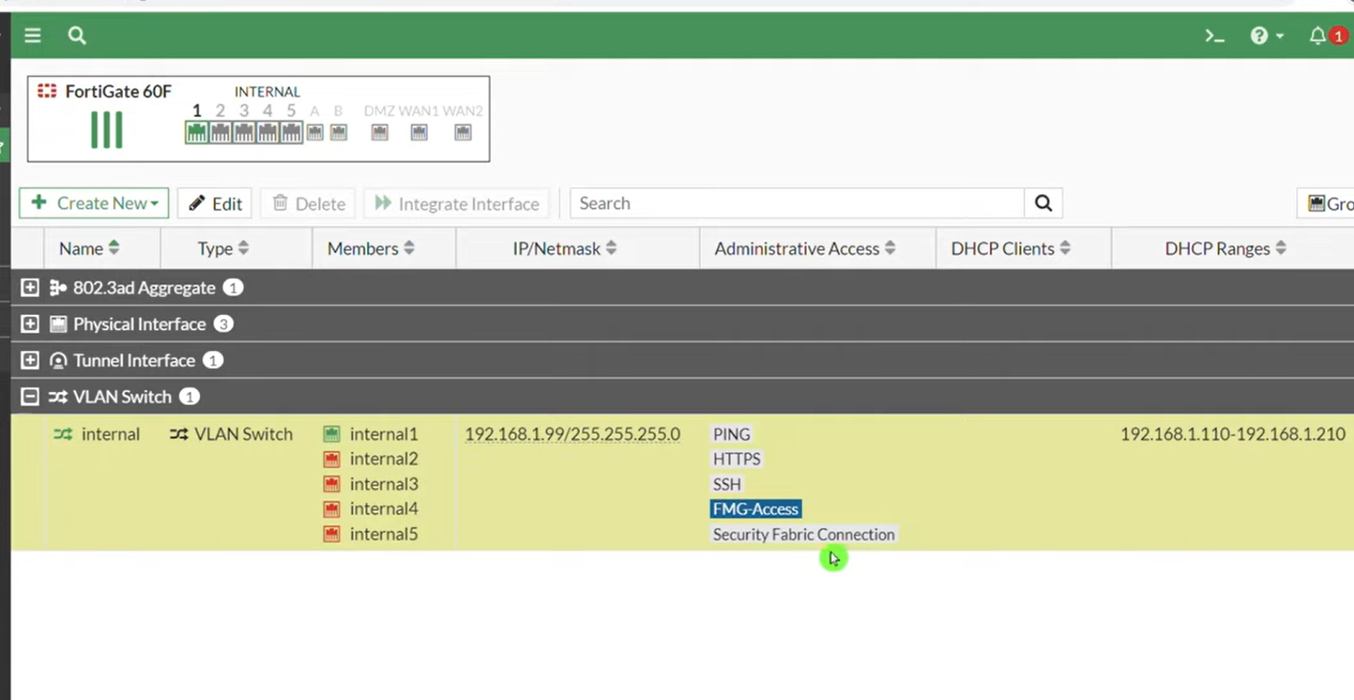

Double click to edit

